CMP9137M - Machine Learning Assignment Detection of Pneumonia in Medical Images and Training Deep Reinforcement Learning Agents.



line 1: 2nd Stephen Rerri-Bekibele  
line 2: *School of Computer Science. University of Lincoln   
(of Affiliation)*line 3: Lincoln, United Kingdom  
line 4: 16663359@students.lincoln.ac.uk

Table of Contents

Introduction 3

Concept 3

A. Supervised and Un-supervised 3

B. Linear regression 3

C. Decision Tree 3

D. Random Forest 3

E. Neural Network 4

F. Logistic regression 4

G. Support Vector Machine 4

H. Naïve Bayes 4

I. Clustering 5

J. Dimensionality Reduction 5

K. Principal Component Analysis (PCA) 5

L. Implementing an Image classifier 5

1) Results of baseline CNN Model 5

2) Results of Hyper tuned model 5

3) Result of regularised model 6

4) Results of Augmented Model 6

5) Result of VGG16 Model 7

Assignment Part 2 7

Appendix **Error! Bookmark not defined.**

*Abstract*— in the past, the problem of Detecting abnormalities in Medical images has been the job of highly skilled doctors with years of training and education. That is now a by-gone age, Machine Learning can now be used to achieve similar and in some cases better results than Human experts. This paper proposes some machine learning models for the purpose of classifying Pneumonia in Medical Images. The results show that certain models are better at image classification than others and the models may sometimes need to be kept in check by a human overseer.

Keywords—machine learning, image classification, training, experts, results, skilled, models, abnormalities (key words)

# Introduction

The goal of this research paper is to demonstrate the detection and classification of Pneumonia in images. But before the approaches used in this paper are discussed, the concept of machine learning classifiers must first be covered.

# Concept

There are a wide range of machine learning classifiers, all inspired by various models and categories and employed in different aspects of problem solving, From Perceptron to Naïve Bayes, Decision Tree, Logistic Regression, K-Nearest Neighbour, Support Vector Machine and Finally, Artificial Neural Networks/ Deep Learning. All of these ‘models’ as they are called, fall into either the supervised or unsupervised category and within the Supervised Category there are two sub categories called Regression and Classification.

## Supervised and Un-supervised

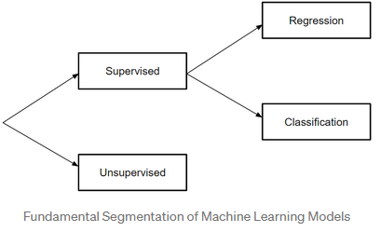

The Supervised category is playfully referred to as supervised learning and involves the learning of a function that maps an input to an output based on example input-out pairs [1].

Unsupervised learning on the other hand is used to draw inferences and find patterns from input data without references to labelled outcomes. The main methods of these type of models are clustering and dimensionality reduction.

## Linear regression

The regression category of the supervised models deals with continuous outputs 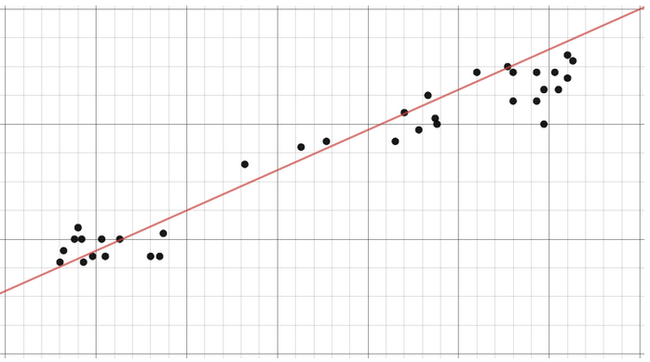

Such as the rate of change of something like an object in motion. The idea of linear regression is to find the gradient y/x that best describes the change in data. Therefore this model cannot be used for classification.

## Decision Tree

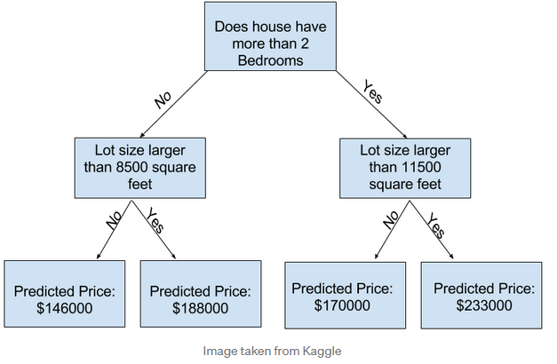

Decision trees on the other hand are more flexible in that they can represent more complex options and divide things into categories therefore they can be used for classification. Decision trees are a popular model because they are useful in operations research, strategic planning and machine learning. Each square above is called a node and the more nodes there are the more accurate the tree. Decision trees are intuitive and thus easy to build but lack accuracy.

## Random Forest

Random forests are an Ensemble learning technique. They build off of decision trees and involve creating multiple decision trees using bootstrapped datasets of original data and randomly selecting a subset of variables at each step of the tree. The mode of all the predictions of each decision tree is then selected by the model. This method of relying on the majority result, reduces the risk of error from using one individual tree.

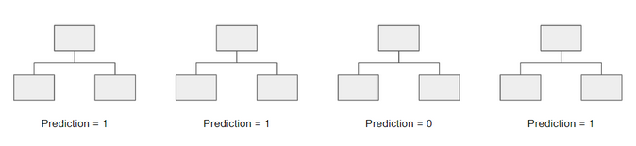

In example, if one decision tree is created, the third one, it would predict a value of 0. However, if the mode of the trees is taken into consideration then the predicted value would be 1.

## Neural Network

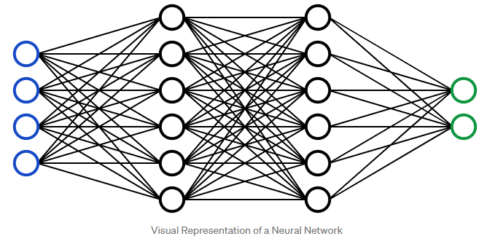A neural network is a connected ‘series of mathematical equations where going through one pathway results in one or more output variables. Blue represents an input layer and black represents hidden layers, while green represent output layers. Each node in the hidden layer represents both a linear function and an activation function that the nodes in the previous layer go through, ultimately leading to an output in the green area. The more heading layers in a neural network the more complex it is and therefore the more capable the network. A Deep neural network is a Neural Network that has a large number of hidden layers.

## Logistic regression

Unlike in regression problems, the output of classification tasks are discrete. Logistic regression is akin to linear regression however it is used to model the probability of a finite number of outcomes, typically two. There are many reasons to logistic regression instead of linear regression when modelling probability. The main one being that a logistic equation is created in such a way that the output values can only be between 0 and 1.

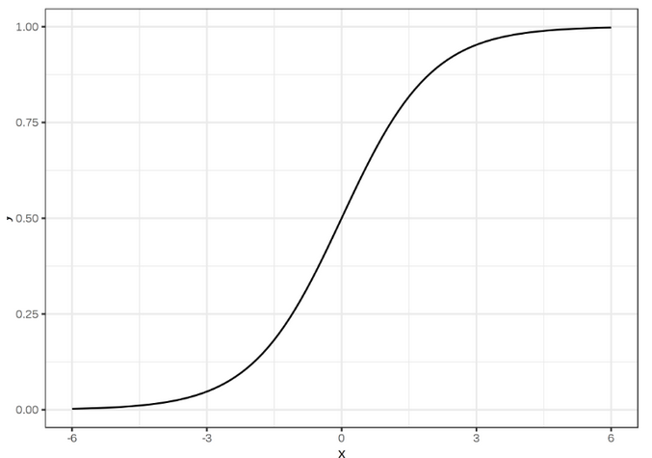

## Support Vector Machine

A support vector machine is a supervised classification technique. It can be model complex systems but is pretty intuitive at the most fundamental level.

If there are two groups of data, an SVM can find a hyperplane such that the groups are separated at the margin between them. There are many planes that can maximise the margin or distance between groups

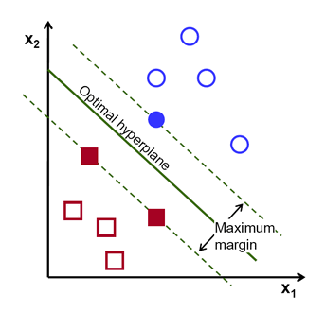

## Naïve Bayes

Naïve bayes is a popular classifier used in datascience, it isdriven by Bayes Theorem.

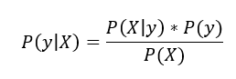

The equation defines the probability of an output y given x as equal to the probability of X given Y multiplies by the probability of Y over the probability of x. With the naïve assumption that variables are independent given the class, it is also possible to rewrite the equation as:



When the denominator is removed P(Y/X) is proportional to the right hand side. 

Therefore, the goal of the equation is to find the class y with the maximum propoportional probability

## Clustering

Clustering is an unsupervised approach usually applied to unlabelled data. 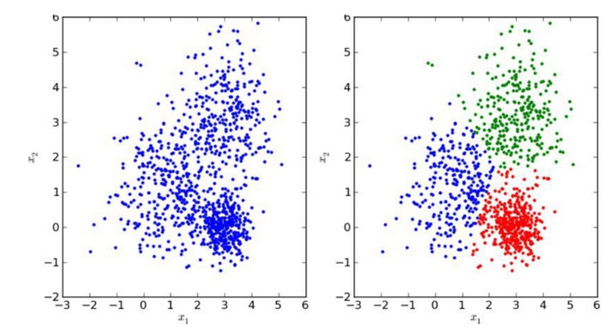

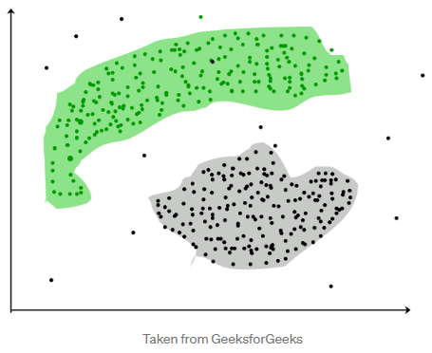

Clustering involves grouping or clustering data points. It is frequently applied to customer segmentation, fraud detection and document classification. Common clustering techniques include k-means clustering, hierarchical clustering, mean shift clustering and density-based clustering. While each technique has a different method in finding clusters, they all aim to achieve grouping and thus classification.

## Dimensionality Reduction

Dimensionality reduction is the process of reducing the number of random variables under consideration by obtaining a set of principal variables [2]. It is the process of reducing the dimension of a feature set. Most dimensionality reduction techniques can be categorized as either feature elimination or feature extraction. A very popular method of dimensionality reduction is called principal component analysis.

## Principal Component Analysis (PCA)

PCA is the last model mentioned in this report. It involves projecting higher dimensional data such as 3D data to a smaller space (2D). While allowing all the original variables of the model to remain.

## Implementing an Image classifier

The First Classifier Implemented in this paper was the CNN based model. I started off with a really basic model comprised of a convolutional layer, pooling layer and Fully connected Layer.

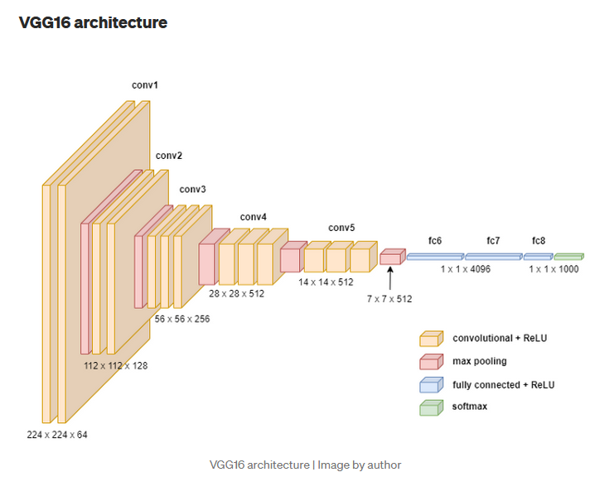

1. Plot of CNN/VGG16 model [5]

### Results of baseline CNN Model

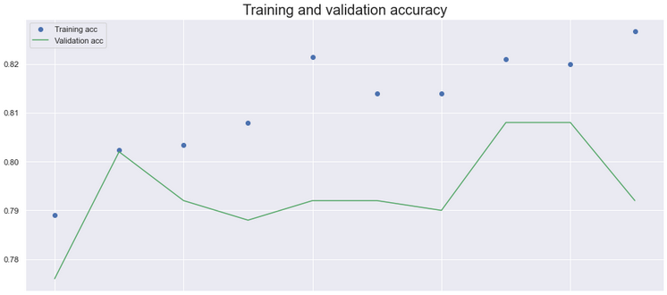

1. Baseline CNN Model

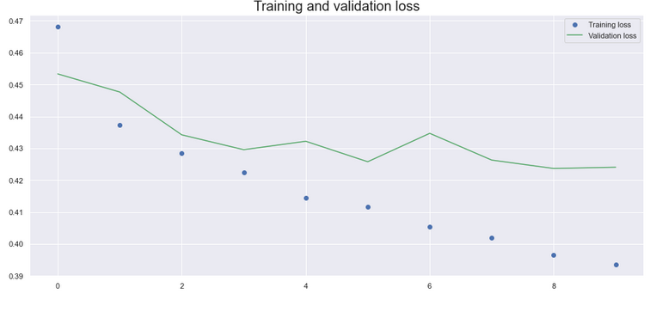

1. Baseline CNN Model

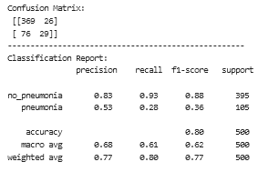

1. Baseline CNN Model

### Results of Hyper tuned model

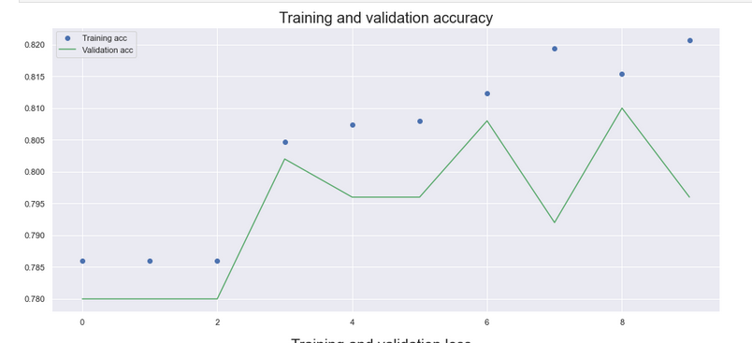

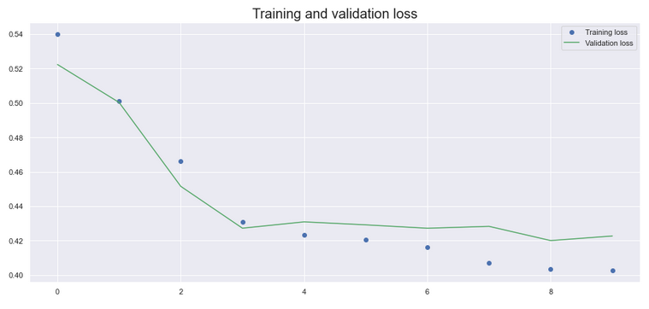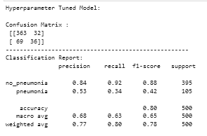

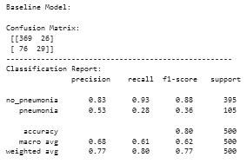

### Result of regularised model

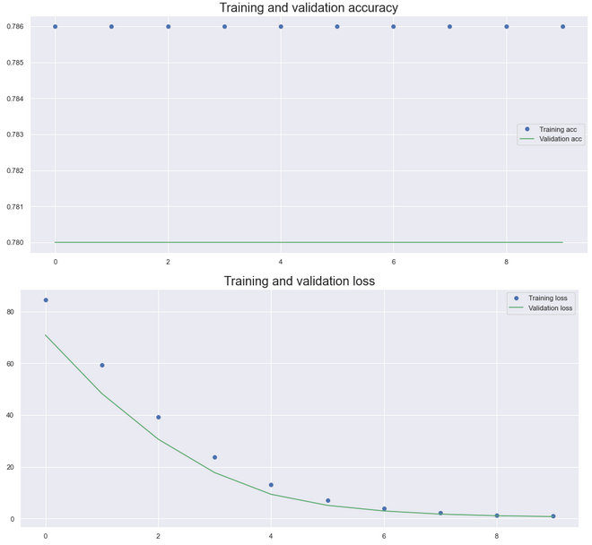

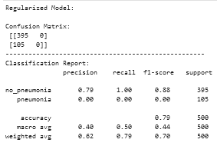

### Results of Augmented Model

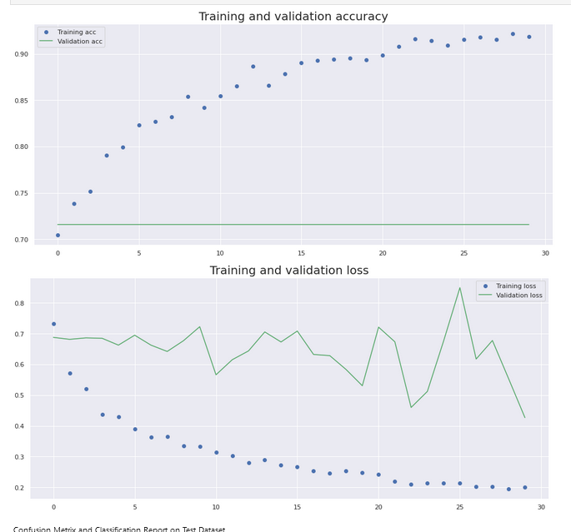

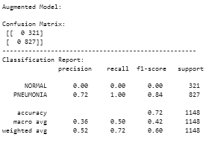

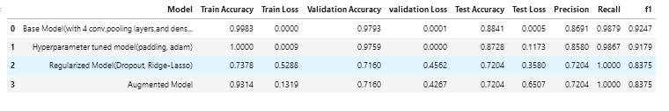

### Result of VGG16 Model

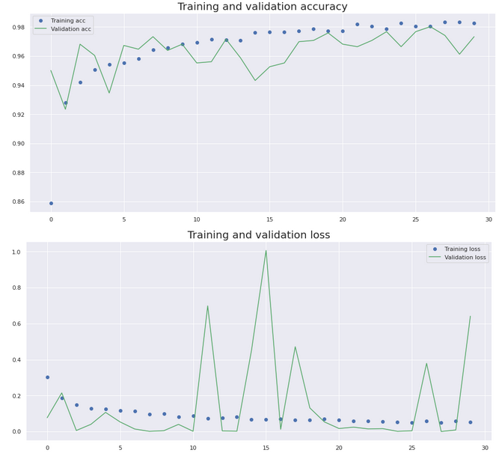

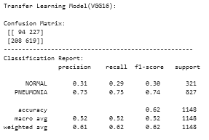

The CNN model was then improved in various ways from tuning the Hyper-parameters to adding Regularization and then augmenting the model. The results showed that the Base model had the highest validation accuracy even when compared to another model such as vgg16 and it also had the highest precision and f1 value while also having the lowest test loss and training loss. However the Augmented and Regularized methods had a higher recall rate. Moreover, the Hyper-parameter tuned model astonishingly had the lowest validation loss at 0. The chosen classifiers were all very good because they all performed significantly well across all. The weakest classifier being the Regularized method which had the highest training loss at 0.5

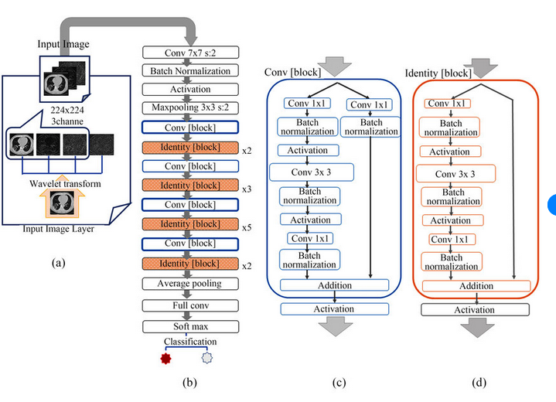

1. Plot of Resnet Model [6]

# Assignment Part 2

The first deep learning model to successfully learn control policies directly through high dimensional sensory input using reinforcement was presented in Atari[7] 2013. The model was a convolutional neural network trained with a variant of Q-learning and using raw pixels to output a value function estimating future rewards. The results showed that the agent outperformed all previous approaches on six games, even surpassing human experts on three of them. Since then the capabilities of Deep reinforcement Learning agents for games have only improved.

In this section the Models, Policies and seeds of agents as well as the performance of said agents will be discussed. The configurations of the model for the agents that were trained are:

|  |  |  |  |
| --- | --- | --- | --- |
| Model | Policy | seed | Learn rate |
| PPO | CnnPolicy | 20 | 0.0000001 |
| PPO | CnnPolicy | 10 | 0.0000001 |
| PPO | MlpPolicy | 20 | 0.060000 |
| PPO | MlpPolicy | 10 | 0.000100 |

|  |  |  |  |
| --- | --- | --- | --- |
| Model | Policy | seed | buffer_size |
| DQN | MlpPolicy | 10 | 200 |
| DQN | CnnPolicy | 10 | 224 |
| DQN | CnnPolicy | 10 | 100 |
| DQN | MlpPolicy | 20 | 100 |

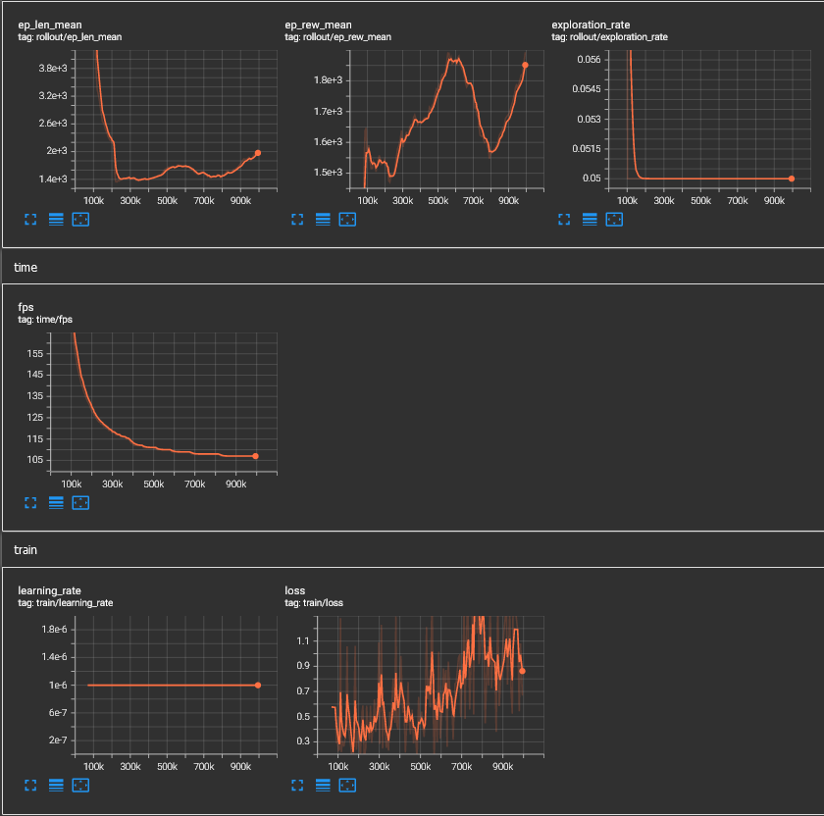

1. DQN cnnpolicy seed 10 buffer_size 224

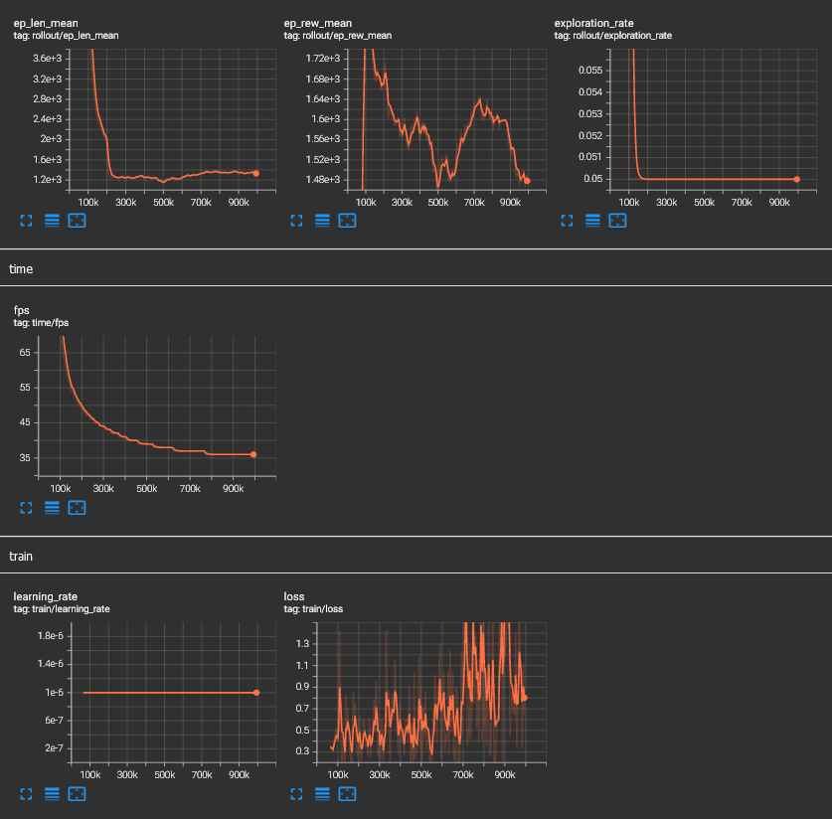

1. DQN Mlp buffer_size 200 seed 10

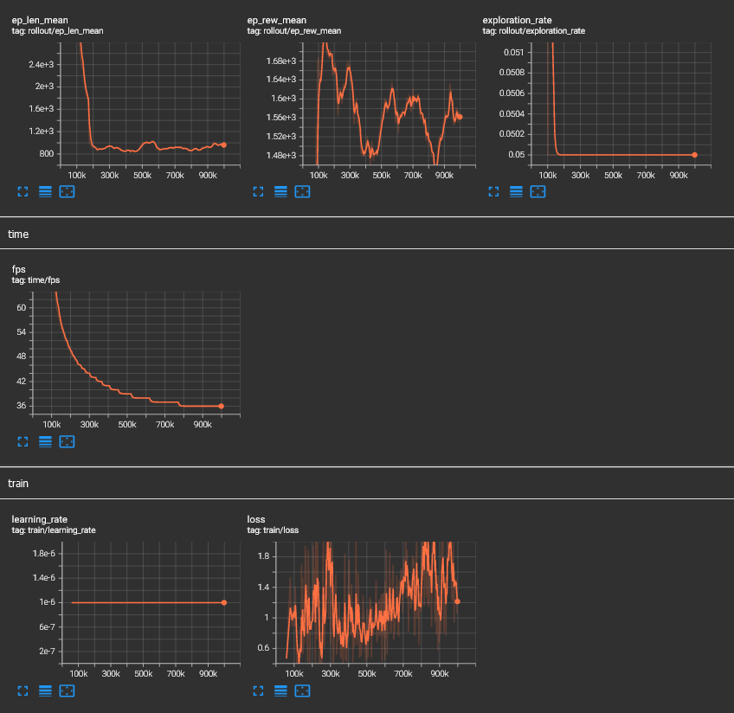

1. DQN mlp buffer_size 100 seed 20

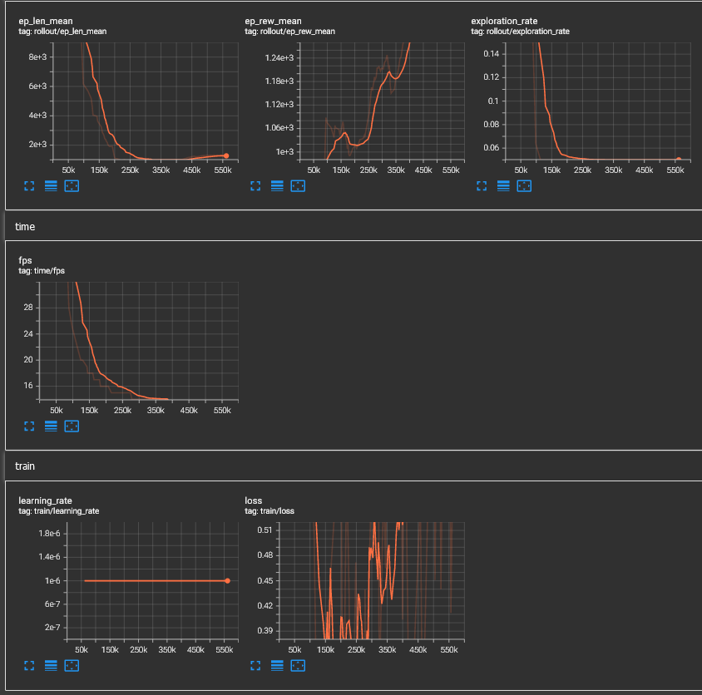

Figure 9 DQN cnn buffer size 100 seed 10

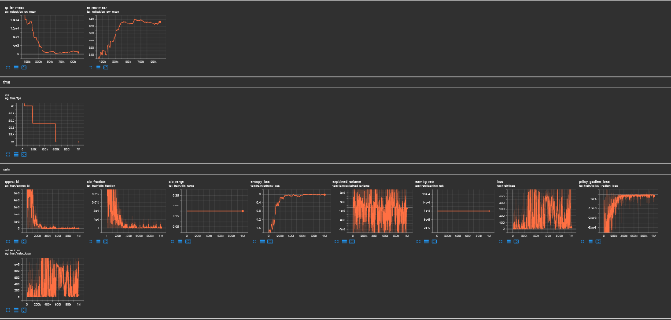

1. PPO mlp seed 10 lr 0.000100

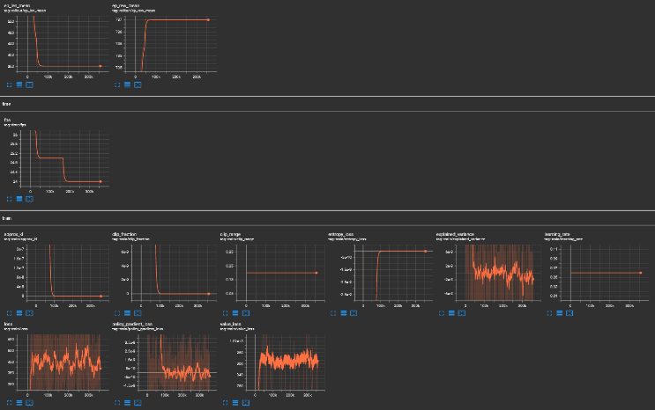

1. Ppo mlp seed 20 lr 0.06000

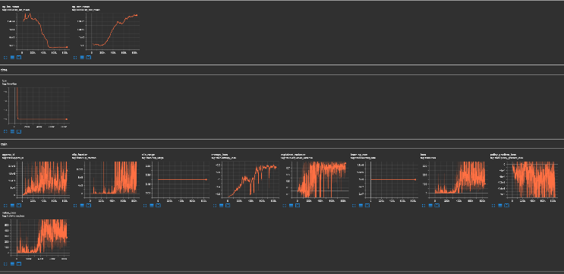

1. PPO cnn seed 20

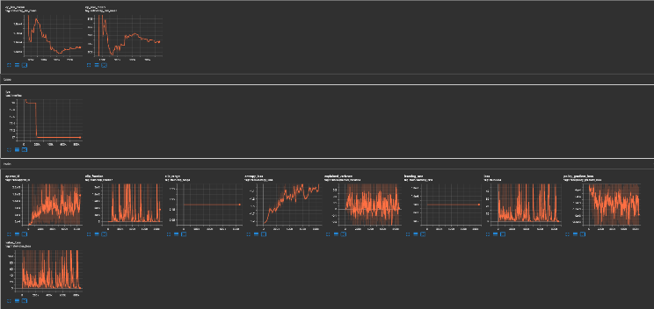

1. PPO cnn seed 10

##### Acknowledgment

I would like to acknowledge the lecturers for letting me experience this masters and Teaching like how one would expect lectures to teach.

##### References

[1] Stuart J. Russell, Peter Norvig, Artificial Intelligence: A Modern Approach (2010), Prentice Hall

[2] Roweis, S. T., Saul, L. K., Nonlinear Dimensionality Reduction by Locally Linear Embedding (2000), Science

[3] Terence Shin. 2020. All Machine Learning Models Explained in 6 Minutes. Available at: <https://towardsdatascience.com/all-machine-learning-models-explained-in-6-minutes-9fe30ff6776a> [Accessed 19.05.2022]

[5] Kenneth Leung. How to easily draw neural network Architecture Diagrams. Available at: <https://towardsdatascience.com/how-to-easily-draw-neural-network-architecture-diagrams-a6b6138ed875> [Accessed 19.05.2022]

[6] Matsuyama, E., 2020. A deep learning interpretable model for novel coronavirus disease (COVID-19) screening with chest CT images. *Journal of Biomedical Science and Engineering*, *13*(07), p.140.

[7] Mnih, V., Kavukcuoglu, K., Silver, D., Graves, A., Antonoglou, I., Wierstra, D. and Riedmiller, M., 2013. Playing atari with deep reinforcement learning. *arXiv preprint arXiv:1312.5602*.